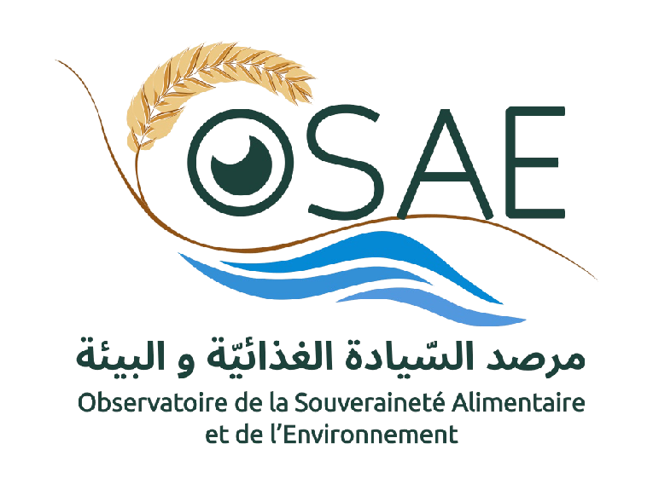
Summer school
“Climate change and Food Dependence: Processes and Risk”
Jerba, 31 August - 6 September 2020
Reduest for Attendance Funding

Surname
Name
Nationality
Country and city of residency
Current Occupation
Transportation | Yes/No
Local Accommodation | Yes/No
Are you currently receiving a scholarship? | Yes/No
Do you have a current fixed income? | Yes/No

